**AI Practical Exam**

Video Games with AI Domain

1. **Minecraft**:

1. Minecraft is one of the largest ever sandbox video games with the ability to play online.

1. Just like the game is complex, so is AI. But its role is no mean feat, as it controls all the NPCs the game has. And also, some external factors.
2. For example, when you throw an eye of ender (an item in the game), the nearest stronghold (a landmark in caves) and leads the eye there.
3. When fighting the ender dragon (final boss) the AI locates the moving position of the player and shoots a fireball precisely at our location.
4. The AI also works when you hit a villager, an iron golem hones in at you, and will not stop hitting you until you or it is dead.
5. When we tame a wolf and hit any NPC, the wolf will again hone into the location of the NPC and will not stop hitting the NPC until the NPC or it is dead.
6. The same goes for hostile mobs, when within 40 blocks of any hostile mob, they will start attacking you.
7. When in the Nether (another world) when trading or bartering with piggins (natives of nether) the AI will not stop them from attacking until you have a piece of gold armor, and trading gold with them will give you several random items in the game.
8. The AI does some very complicated calculations when in the nether because when you travel the nether, you cover a lot of distance in the overworld. Creating a portal thirty blocks away from your original portal will put a large amount of distance between you and your first portal in the overworld.
9. While online, the AI sorts you to a server where there is a place for a player to play.

2. **Pokémon Unite**:

1. Pokémon Unite is a MOBA video game.

2. It pitches 5 teammates against 5 enemies.

3. The aim is to collect energy from defeating another Pokémon and scoring it to the enemy’s goal.

4. The AI has a very crucial role here.

5. It controls all the various Pokémon, and spawns’ new ones at random times.

6. Some give just energy while some give buffs.

7. The different unranked modes like random and training have just AI-controlled teammates and enemies.

8. When you risk de-ranking, AI bots will join your ranked matches.

9. Without this AI it is as clear as day that the game will be a humongous bust

10. Thus the AI in Pokémon unite is as Important as Minecraft.

Smart City: Chennai

1. The Chennai Smart City has undertaken multiple projects in an effort of making the city a better place to be.
2. They’ve created multilevel parking are in multiple places for better parking, their traffic system has become intelligent and reduced accidents caused on roads and much more.
3. Their focus areas are Smart Mobility, Smart Technology, Smart Environment, Smart Water, and Energy.
4. They’ve created shared bike areas, where people can pick up any bikes to use and return later.
5. And to make sure covid doesn’t spread, they have installed smart classrooms for children to study in safety.
6. Now under smart environment, 5 projects have been undertaken and 4 have been completed while 1 is in progress
7. Smart mobility has 8 projects of which 4 have been completed, 3 in progress, and 1 in its tendering stage
8. Smart water has 4 projects, of which 2 are in their DPR prep, 3 are in progress, and 1 in its tendering stage
9. Smart energy has 5 projects of which 2 have been completed and 3 in progress
10. Smart Tech has 6 projects of which 2 are completed, 3 are in progress, and 1 is in its tendering stage.

Smart School Drawing

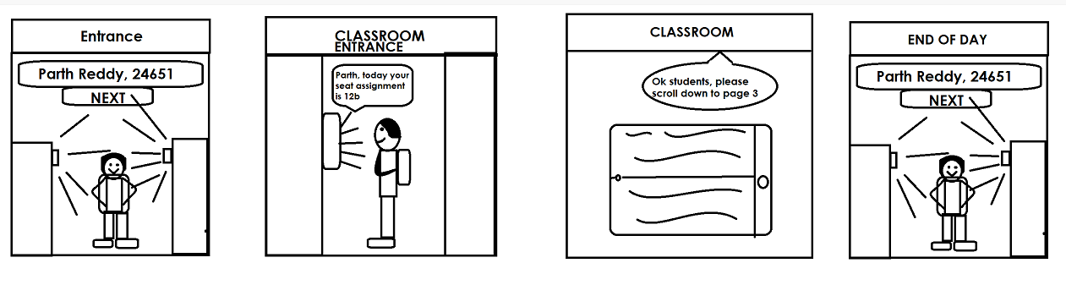

**Letter to 2030 future self**

Station House,  
Airforce Station, Kalina, Santacruz W

Mumbai: 400029

30th November 2021

Dear Future Self,

Hope this letter finds you in good health. How is the future? All the tech, cities, and ease should be keeping you happy. (Smiles and then chuckles) Hope it isn’t WW3 out there! Hahaha! Though seriously. Hope all the tech and power haven’t made people go hungry for power and start a WW. I hope you don’t become one of them.

Anyways, what all tech is there? Self-driving cars? Flying cars? Although that just becomes a plane. Talking about planes, are there any planes in 2030? Or have you guys made teleporters, and if you have, are they stuck in one place, or are they personal for everybody? What about robots? Are working with or above robots? Or are people just cyborgs now (you know, people with both robot pieces and human body parts)? What about food, what crazy inventions have the chefs of 2030 made yet? Oh! I almost forgot! What about our sister? How’s her restaurant doing? Or is she doing something else? You know how she kept telling me she wanted to be a chef when she grew up. What are you doing? Are you a famous gamer, or a soldier for the government, trying to keep the country safe? Ooh… speaking of protection, what new kinds of weapons have popped up?

Bruh, you are so lucky! Me, a teen you, here in 2021, with all this covid-19 stuff, and you out there in the amazing futuristic world! Man, I’m jealous now! Oh well, you’re lucky, and so am I. Hope you stay safe and make sure to better the world with everything you do… **not destroy it.** On that note, have a great life my friend, have a great life, and always keep you and others around you smiling!

Sincerely,

Your past self

Parth